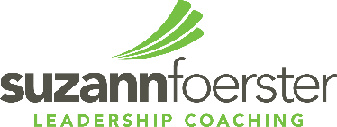

**Bio.**

**ke**

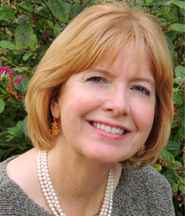

**Pam Erhardt, Ph.D.**

Healthcare Leadership Coach, Suzann Foerster Leadership Coaching

Pam specializes in serving leaders in transition. They may be in transition because they’ve shifted jobs or shifted roles within the organization. They may be in transition because their company or team is on a growth trajectory or needs to be, and they’ve discovered that growth requires new competencies and skills. Or they may recognize that in order to be promoted, they need to develop their leadership style, improve their corporate relationships or their ability to manage up, down or across.

Pam is unique among coaches. She has first-hand business leadership experience leading to a deep understanding of the pressures of profitability, growth and managing quality. She also brings a finely honed ability to help leaders recognize how their behavior impacts others, and how to inspire colleagues to meet organizational goals. Pam focuses on the successful integration of mindful leadership practices, human performance, and business strategy.

Pam holds a bachelors degree in Health Science & Physical Therapy; a masters degree in Organizational Development; and a doctorate in Human and Organizational Psychology. Her clients include: Amgen, Northrop Grumman, Dole Foods, Lockheed Martin, Warner Brothers, Conoco Phillips, Cedars Sinai Medical Center, Nissan, Claremont Graduate University, DTS Digital Entertainment, Crystal Stairs, Wellpoint Health Systems, The University of Southern California, Pacific Coast Capital Partners, and the Los Angeles Regional Food Bank. She is the Managing Partner at Corporate Coaching International and she sits on the Board of Directors of The Bloom Again Foundation. In addition, she has earned her Certified Professional Coach credential (PCC) through the International Coach Federation.

Pam Erhardt ǀ LinneaNCA@gmail.com ǀ 202.290.1255 ǀ skype: linneanc